Title of Abstract (Font Type: Arial and Font Size: 14)
Author, ¹* Author, ¹ Third, ² and corresponding author. ²
¹*Presenting Author-
¹ Affiliation:
E-mail:

Abstract:

The main text and the author names are in Arial, 12 points for the Author names,13 points for the body of the abstract,10 points for the references and Figure caption 11 points.
Type or paste your text into this file. Please keep the page margins the same as set here. Paragraphs are justified (straight-edged) on both left and right.
Use single-line spacing and leave a line space between paragraphs. This helps readability. If you would like to insert a figure you can do so. If you want, you can wrap the text to flow around the figure. Remember to include a figure caption.
The abstract deadline is 20th October 2025. The limit for your abstract is one page. The organizing committee reserves the right to edit abstracts for clarity or correctness of English, but will consult the author if any significant changes are needed.
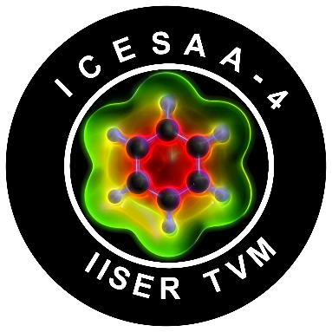
Figure 1: Reference Figure

References
- Rodríguez-Córdoba W, Gutiérrez-Arzaluz L, Cortés-Guzmán F, Peon J. Chem. Commun. 2021, 57, 12218–12235.

